MINI PROJECT REPORT

ON

FUNCTIONAL BLOCKCHAIN SIMULATOR

Submitted by
KAPARTHI ADHI VENKATA DHANUSH
NC.SC.U4CSE24210

For
23CSE212- Functional Programming using Haskell
IV Semester
B.Tech. CSE

School of Computing
Amrita Vishwa Vidyapeetham, Nagercoil

Index

S. No | Content | Page No
1 | Abstract | 3
2 | Introduction | 4
3 | Problem Statement | 5
4 | Objectives | 5-6
5 | Literature Review | 6–8
6 | System Design | 8
6.1 | Architecture Diagram | 9
6.2 | Flowchart | 10
6.3 | Algorithm Steps | 11-12
7 | Methodology | 12-13
8 | Implementation | 14-17
9 | Testing and Results | 17
10 | Discussion | 18
11 | Conclusion | 18
12 | Future Enhancement | 19
13 | References | 19
14 | GitHub Link | 19

1. Abstract
Problem
With the rapid growth of digital transactions and online systems, maintaining data integrity, transparency, and security has become a major challenge. Traditional centralized systems rely on a single authority to verify and store data, which makes them vulnerable to data manipulation, cyberattacks, and single-point failures. Blockchain technology solves this issue by maintaining a distributed and immutable ledger, but understanding how blockchain works internally can be difficult for students and developers. Therefore, there is a need for a simplified system that demonstrates the core concepts of blockchain in an educational and practical way.

Objective
The main objective of this project is to develop a Functional Blockchain Simulator using Haskell that demonstrates the fundamental concepts of blockchain technology such as block creation, hashing, transaction handling, proof-of-work mining, and chain validation. The project also aims to showcase how functional programming principles like immutability, pure functions, and strong type systems can be effectively used to build secure and reliable systems.

Method Used
The project is implemented using the Haskell programming language, which supports functional programming paradigms. The system defines blocks and transactions using Algebraic Data Types (ADT) and maintains the blockchain as an immutable chain of blocks. A SHA-256 hashing mechanism is used to generate secure hashes for each block. The project implements a Proof-of-Work mining algorithm where a valid block hash is generated based on a defined difficulty level. The backend exposes APIs for adding transactions, mining blocks, and validating the blockchain. A simple frontend interface allows users to interact with the system and visualize the blockchain.

Outcome
The developed system successfully demonstrates how blockchain works internally. Users can add transactions, mine new blocks, and view the blockchain structure in a clear and interactive way. The project highlights the benefits of functional programming in building secure and reliable systems, and it provides an educational tool for understanding blockchain concepts such as immutability, distributed ledgers, and cryptographic hashing. The final result is a working blockchain simulation that combines Haskell backend logic with a modern user interface for visualization.

2. Introduction
Overview of Selected Haskell Concept
Haskell is a purely functional programming language known for its strong type system, lazy evaluation, and emphasis on immutability. Unlike imperative programming languages that rely on changing program states, Haskell focuses on evaluating expressions and using pure functions. These characteristics make Haskell highly suitable for developing reliable and secure systems where predictable behavior and data integrity are important.
One of the key concepts used in this project is immutability, where data cannot be modified once it is created. Instead of altering existing data, new data structures are created when changes are required. This concept is very important in blockchain systems because blocks, once created and added to the chain, should not be altered. Haskell naturally supports this behavior through immutable data structures.
Another important concept used in this project is Algebraic Data Types (ADT). ADTs allow developers to define custom data structures in a clear and structured manner. In this project, ADTs are used to define the structure of blocks and transactions within the blockchain. Each block contains details such as the block index, timestamp, transaction data, previous block hash, current block hash, and nonce value used during mining.
The project also uses pure functions, which are functions that always produce the same output for the same input and do not cause side effects. Pure functions are useful in blockchain systems for operations like hashing and block validation because they ensure consistent and predictable results.
In addition, IO Monads are used to handle input and output operations such as receiving transactions from users, interacting with APIs, and displaying blockchain data. Monads help manage side effects while maintaining the functional programming structure of Haskell.

Real-World Relevance
Blockchain technology has become an important component of many modern digital systems. It is widely used in cryptocurrencies such as Bitcoin and Ethereum, where it ensures secure and transparent financial transactions without the need for a central authority. Beyond finance, blockchain is also used in areas such as supply chain management, digital identity verification, healthcare data management, and secure voting systems.
Understanding how blockchain works internally is essential for students and developers who want to work with modern distributed systems. However, real blockchain systems are often complex and difficult to study directly. Therefore, developing a simplified blockchain simulator helps in learning the fundamental principles behind blockchain technology.
This project demonstrates how functional programming concepts in Haskell can be applied to build systems that require strong reliability and data integrity. By implementing features such as block creation, hashing, mining, and chain validation, the project provides a practical demonstration of blockchain operations. It also highlights the advantages of functional programming in developing secure and maintainable software systems.
3. Problem Statement
Modern digital systems require secure and reliable methods for storing and verifying data. Traditional centralized systems depend on a single authority to manage and control data, which can lead to several issues such as data tampering, security vulnerabilities, lack of transparency, and single points of failure. In many applications such as financial transactions, data sharing, and digital identity management, ensuring the integrity and authenticity of data is extremely important.
Blockchain technology provides a solution to these problems by maintaining a distributed and immutable ledger where each block of data is securely linked to the previous one using cryptographic hashing. However, real-world blockchain platforms are complex and involve advanced networking, distributed consensus mechanisms, and large-scale infrastructure. This complexity makes it difficult for students and beginners to understand how the internal mechanisms of blockchain operate.
Therefore, the problem addressed in this project is the need to develop a simplified system that demonstrates the core concepts of blockchain technology in a clear and understandable way. The project implements a Functional Blockchain Simulator using the Haskell programming language, which focuses on demonstrating important blockchain operations such as block creation, transaction handling, cryptographic hashing, proof-of-work mining, and blockchain validation.
The system allows users to add transactions, mine new blocks, and verify the integrity of the blockchain through a user interface. By implementing these features using functional programming concepts such as immutability, pure functions, and strong type systems, the project provides a practical model that helps users understand how blockchain systems maintain security, transparency, and data integrity.

4. Objectives
Learning Objective
The primary learning objective of this project is to understand how functional programming concepts can be applied to build secure and reliable systems. Through the development of the Functional Blockchain Simulator, students gain practical experience with important Haskell programming concepts such as immutability, pure functions, algebraic data types (ADT), recursion, and monads. The project helps in understanding how these concepts contribute to writing predictable and maintainable code.
Another important learning objective is to study the fundamental principles of blockchain technology. This includes understanding how blocks are structured, how cryptographic hashing ensures data integrity, and how proof-of-work mining helps maintain the security of the blockchain network. By implementing these features step by step, students develop a deeper understanding of distributed ledger systems and their working mechanisms.
The project also helps students develop problem-solving skills by applying theoretical concepts from functional programming and cryptography to a real-world inspired application. Additionally, it provides experience in integrating backend logic with a user interface, which improves practical software development skills.

Implementation Objective
The main implementation objective of this project is to design and develop a simplified blockchain simulation system using the Haskell programming language. The system aims to demonstrate the key functionalities of blockchain technology in a structured and interactive manner.
The implementation focuses on creating a blockchain data structure where each block contains important attributes such as index, timestamp, transaction details, previous hash, current hash, and nonce value. The project implements a proof-of-work mining mechanism that generates valid block hashes based on a predefined difficulty level.
Another objective is to implement transaction handling, where users can add transaction data that will be included in newly mined blocks. The system also includes a blockchain validation feature that checks the integrity of the entire chain by verifying the hash links between blocks.
In addition, the project integrates a simple user interface that allows users to interact with the blockchain simulator by adding transactions, mining blocks, and viewing the blockchain structure. The final goal is to create a functional system that clearly demonstrates the working principles of blockchain while highlighting the benefits of functional programming using Haskell.

5. Literature Review
Introduction
Blockchain technology has emerged as one of the most significant innovations in modern computing, providing a secure and decentralized way to store and manage digital data. It was first introduced through Bitcoin in 2008 by Satoshi Nakamoto, where it served as a distributed ledger for recording cryptocurrency transactions. Since then, blockchain has been widely studied and applied in various domains such as finance, healthcare, supply chain management, digital identity systems, and cybersecurity.
The core concept of blockchain involves storing data in blocks that are linked together using cryptographic hashes. Each block contains a reference to the previous block’s hash, forming a continuous and immutable chain. This structure ensures that once data is recorded in the blockchain, it cannot be easily modified without affecting all subsequent blocks, thereby maintaining data integrity and transparency.
Researchers and developers have proposed several algorithms and approaches to ensure the security, validation, and reliability of blockchain systems. The most important among them include cryptographic hashing algorithms, consensus mechanisms, and block validation methods.
Existing Algorithms
Cryptographic Hashing Algorithms
Cryptographic hashing plays a crucial role in blockchain technology. A hash function takes an input of any size and produces a fixed-length output called a hash. The hash uniquely represents the input data, and even a small change in the input results in a completely different hash value.
One of the most widely used hashing algorithms in blockchain systems is SHA-256 (Secure Hash Algorithm 256-bit). SHA-256 is used in Bitcoin and many other blockchain platforms to generate secure block hashes. The algorithm is designed to be computationally efficient while maintaining strong resistance against collisions and tampering.
In blockchain systems, hashing is used to link blocks together. Each block contains the hash of the previous block, which ensures that if any data in a previous block is modified, the entire chain becomes invalid. This mechanism provides strong protection against unauthorized modifications.

Proof-of-Work (PoW) Algorithm
Proof-of-Work is one of the earliest and most widely used consensus mechanisms in blockchain networks. In this approach, miners compete to solve a computational puzzle in order to add a new block to the blockchain. The puzzle usually involves finding a nonce value that produces a hash with a specific pattern, such as a certain number of leading zeros.
The mining process requires computational effort, which prevents malicious actors from easily modifying the blockchain. Once a miner successfully finds a valid hash, the new block is added to the blockchain and the solution is verified by other nodes in the network.
Although Proof-of-Work provides strong security, it also requires significant computational resources and energy consumption. Despite this limitation, it remains an important algorithm for understanding the fundamental working principles of blockchain systems.

Blockchain Validation Algorithm
Blockchain validation ensures the integrity and correctness of the entire chain of blocks. The validation process typically involves verifying several conditions:
- The hash of each block is correctly calculated.
- Each block contains the correct hash of the previous block.
- The block data has not been altered after the block was created.
- The proof-of-work condition is satisfied.
If any of these conditions fail, the blockchain is considered invalid. Validation algorithms are essential for maintaining trust and consistency within blockchain systems.
Comparison of Approaches
Different blockchain implementations and algorithms offer various advantages and trade-offs depending on the system requirements. The following comparison highlights some of the common approaches used in blockchain systems.
Approach | Description | Advantages | Limitations
Cryptographic Hashing | Uses hash functions like SHA-256 to secure data and link blocks | Ensures data integrity and tamper resistance | Does not provide consensus by itself
Proof-of-Work | Mining process that requires solving computational puzzles | High security and strong resistance to attacks | High energy consumption
Blockchain Validation | Verifies the integrity and correctness of the blockchain | Ensures trust and reliability of stored data | Requires continuous verification

In this project, a simplified blockchain model is implemented using hashing and proof-of-work concepts. The goal is not to replicate full-scale blockchain networks but to demonstrate the core principles that make blockchain systems secure and reliable. By implementing these algorithms in Haskell using functional programming principles, the project highlights how immutable data structures and pure functions can support secure system design.

6. System Design
The system design of the Functional Blockchain Simulator describes the overall structure of the system and how different components interact with each other to perform blockchain operations. The system follows a modular architecture in which each component is responsible for a specific task such as transaction handling, block creation, mining, and blockchain validation.
The application is divided into two main parts: the frontend interface and the backend blockchain logic. The frontend provides an interactive dashboard where users can enter transaction details, initiate block mining, and visualize the blockchain structure. It communicates with the backend through API requests.
The backend is implemented using the Haskell programming language, where the core blockchain logic is developed using functional programming principles. The backend handles important processes such as creating blocks, generating hashes using cryptographic functions, validating the blockchain, and managing transactions.
When a user submits a transaction through the interface, the request is sent to the backend API where the transaction is temporarily stored. When the mining process is initiated, the system collects the pending transactions and creates a new block. The mining algorithm then calculates a valid hash by adjusting the nonce value until the required difficulty condition is satisfied.
Once a valid hash is found, the new block is added to the blockchain. The system then verifies the integrity of the chain by checking whether each block correctly references the previous block’s hash. Finally, the updated blockchain information is returned to the user interface for visualization.
This modular design improves the maintainability and clarity of the system while demonstrating the key principles of blockchain technology such as immutability, cryptographic hashing, and secure data linking.

Architecture Diagram
The architecture diagram illustrates the overall structure of the Functional Blockchain Simulator and the interaction between its main components. The system follows a layered architecture consisting of the user interface, API layer, and blockchain core logic. The user interacts with the system through the frontend to submit transactions and initiate the mining process. These requests are processed by the backend API implemented in Haskell. The blockchain core module performs operations such as block creation, hashing, proof-of-work mining, and chain validation. The resulting blockchain data is then returned to the user interface for visualization. This architecture ensures clear separation between the presentation layer and the blockchain processing logic.

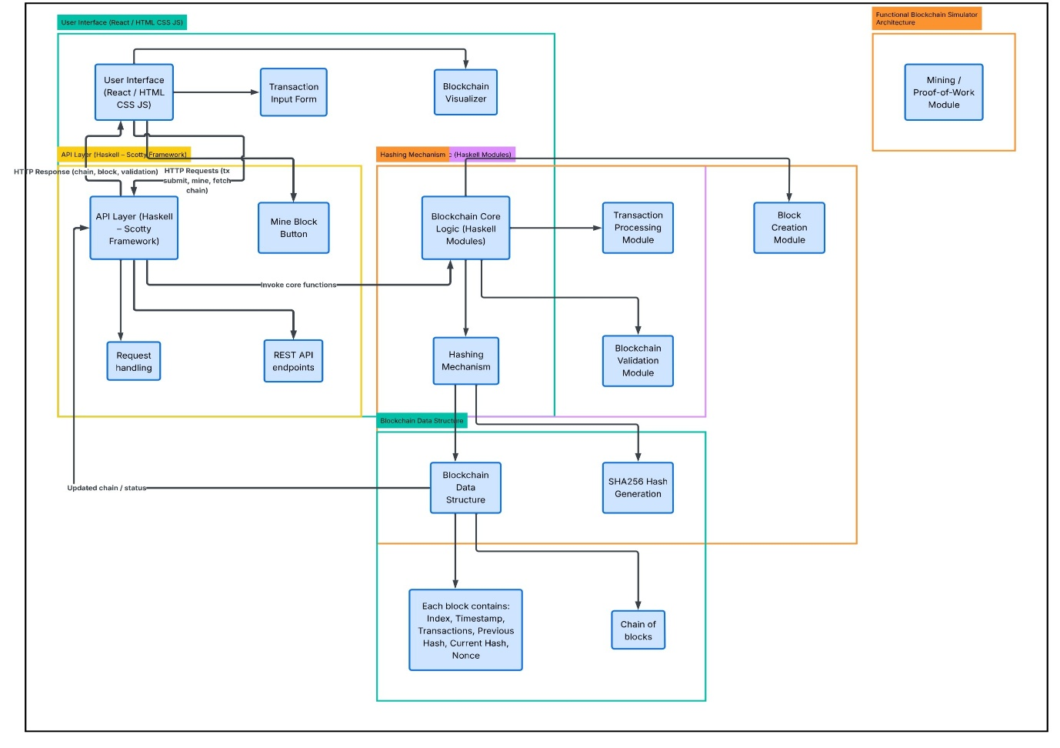
Figure 1: System Architecture of the Functional Blockchain Simulator
Flowchart
The flowchart illustrates the step-by-step process followed by the Functional Blockchain Simulator. The process begins when the user enters transaction details through the interface. The transaction is stored temporarily until the mining process is initiated. During mining, the system creates a new block and generates a hash using the proof-of-work algorithm by adjusting the nonce value. Once a valid hash satisfying the difficulty condition is found, the block is added to the blockchain. Finally, the system validates the blockchain and displays the updated chain to the user.

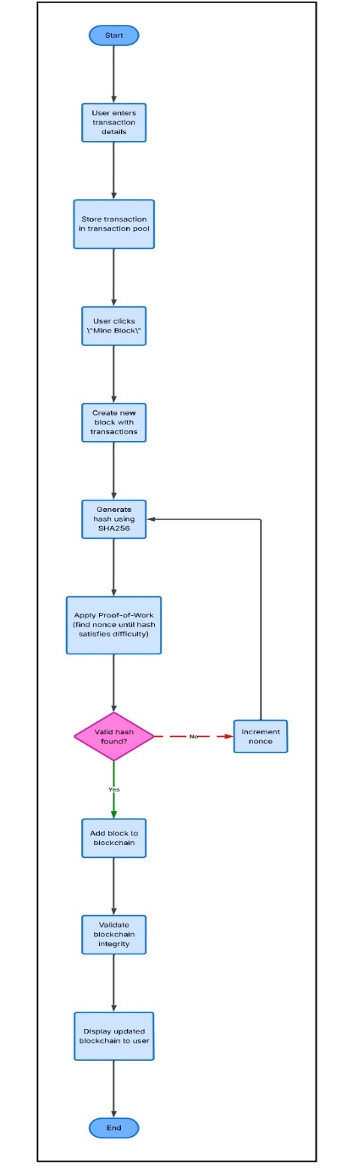
Figure 2: Flowchart of Blockchain Transaction and Mining Process
Algorithm Steps
Algorithm: Add Transaction
- Start the process.
- Receive transaction details from the user.
- Validate the transaction input.
- Store the transaction in the transaction pool.
- Display confirmation to the user.
Algorithm: Mine Block
- Start mining process.
- Collect pending transactions.
- Create a new block with transaction data.
- Initialize nonce value.
- Generate block hash using SHA256.
- Check if the hash satisfies the difficulty condition.
- If not satisfied, increment nonce and generate hash again.
- Repeat until a valid hash is found.
- Add the block to the blockchain.
- Display the updated blockchain.

Algorithm: Validate Blockchain
- Start validation process.
- Traverse each block in the blockchain.
- Recalculate the hash of each block.
- Compare the recalculated hash with the stored hash.
- Check if each block correctly references the previous block hash.
- If all checks pass, the blockchain is valid.
- Otherwise, mark the blockchain as invalid.
- End validation.

Data Structures Used
1. Block Structure
Each block in the blockchain contains the following fields:
- Index – Position of the block in the chain
- Timestamp – Time when the block was created
- Transactions – List of transactions included in the block
- Previous Hash – Hash value of the previous block
- Current Hash – Hash generated for the current block
- Nonce – Value used during the mining process

2. Transaction Structure
Each transaction contains:
- Sender Address
- Receiver Address
- Transaction Amount

3. Blockchain Structure
The blockchain is implemented as a list of blocks, where each block references the hash of the previous block. This structure ensures immutability and maintains the chronological order of transactions.

7. Methodology
The methodology of this project explains the technologies used and the steps followed to implement the Functional Blockchain Simulator. The system is developed using a structured approach to demonstrate the working principles of blockchain technology using functional programming concepts.

Programming Language
The project is implemented using the Haskell programming language, which is a purely functional programming language known for its strong type system and immutable data structures. Haskell allows developers to build reliable and predictable systems using pure functions and functional programming principles. In this project, Haskell is used to implement the core blockchain logic such as block creation, hashing, mining, and blockchain validation.

Platform
The development and execution of the project are carried out on a Linux/Windows environment. The backend server is implemented using Haskell libraries and frameworks such as Scotty for building REST APIs and Aeson for handling JSON data. The frontend interface is developed using HTML, CSS, JavaScript, or React to provide an interactive user interface for visualizing blockchain operations.

Implementation Steps
The implementation of the system is carried out in the following steps:
- Define Data Structures
The structure of blocks and transactions is defined using Algebraic Data Types (ADT) in Haskell.
- Create Genesis Block
The first block of the blockchain, known as the genesis block, is created with predefined values.
- Implement Transaction Handling
The system allows users to enter transaction details which are stored temporarily before mining.
- Develop Hashing Mechanism
A cryptographic hashing function (SHA-256) is implemented to generate unique hashes for each block.
- Implement Mining Algorithm
A proof-of-work mining mechanism is developed where the system searches for a valid hash by adjusting the nonce value.
- Add Block to Blockchain
After successful mining, the new block is added to the blockchain with a reference to the previous block’s hash.
- Blockchain Validation
The system verifies the integrity of the blockchain by checking the hashes and block connections.
- User Interface Integration
A frontend interface is connected to the backend API to allow users to add transactions, mine blocks, and visualize the blockchain.

8. Implementation
Core Logic Explanation
The Functional Blockchain Simulator is implemented using a combination of Haskell for backend logic and React with modern web technologies for the frontend interface. The backend is responsible for managing blockchain operations such as creating blocks, processing transactions, mining new blocks using a proof-of-work algorithm, and validating the blockchain. The frontend provides an interactive dashboard that allows users to submit transactions, mine blocks, and visualize the blockchain.
The backend project is organized into multiple Haskell modules located in the backend/src directory. The Blockchain.hs file contains the main blockchain logic including block creation, hashing, mining, and validation. The Api.hs module handles REST API endpoints that allow the frontend to communicate with the backend server. The Main.hs file initializes the server and starts the application.
When a user enters transaction details in the frontend interface, the data is sent to the backend through an API request. The backend stores the transaction temporarily until the mining process begins. During mining, the system creates a new block containing the transaction data and calculates a cryptographic hash. A proof-of-work algorithm repeatedly changes the nonce value until a hash satisfying the required difficulty level is found. Once a valid hash is generated, the block is added to the blockchain and the updated chain is returned to the frontend for visualization.
The frontend application, located in the frontend directory, is developed using React with Vite and Tailwind CSS. It displays the blockchain data in a structured format and allows users to interact with the system easily.

Important Code Snippets
Block Data Structure (Haskell)
The block structure defines the information stored in each block of the blockchain.
1. data Block = Block { index :: Int , timestamp :: String , transactions :: [Transaction]
, previousHash :: String , hash :: String , nonce :: Int }

This data structure represents the core unit of the blockchain and contains essential information required for linking blocks securely.

Hash Generation Function
This function generates a hash value for each block using block data and nonce value.
1. calculateHash :: Block -> String
2. calculateHash block =
3. sha256 (show (index block) ++ timestamp block ++ show (transactions block) ++ previousHash block ++ show (nonce block))
The hash ensures that the block contents remain unchanged after creation.
Mining Algorithm (Proof of Work)
The mining algorithm repeatedly changes the nonce value until the hash satisfies the required difficulty level.
1. mineBlock :: Block -> Int -> Block
2. mineBlock block difficulty =
3. let target = replicate difficulty '0'
4. newHash = calculateHash block
5. in if take difficulty newHash == target
6. then block { hash = newHash }
7. else mineBlock block { nonce = nonce block + 1 } difficulty

This process ensures that adding new blocks requires computational effort, improving the security of the blockchain.

API Endpoint Example
The API module provides endpoints that allow the frontend to interact with the blockchain system.
1. post "/mine" $ do
2. newBlock <- minePendingTransactions
3. json newBlock

This endpoint triggers the mining process and returns the newly created block.

Screenshots of Execution
Transaction Input Interface
This interface allows the user to enter transaction details such as sender address, receiver address, and transaction amount. After entering the required information, the user can submit the transaction using the submit button. The transaction is then sent to the backend system and stored temporarily in the transaction pool until the mining process begins.
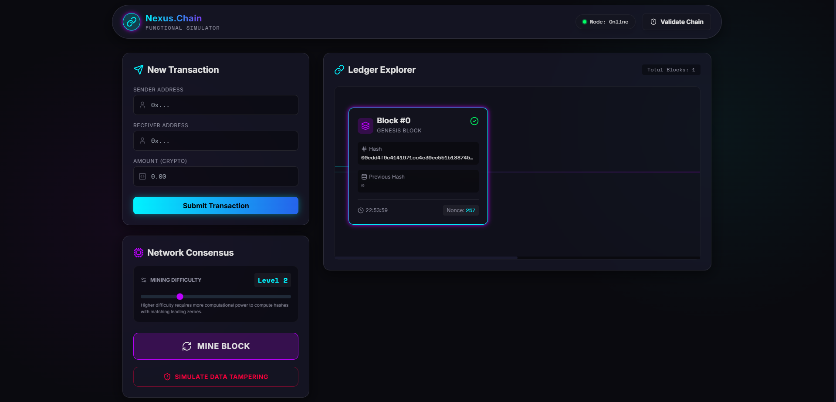
Figure 3: Transaction Input Interface
Transaction Successfully Added
This screen shows that the transaction has been successfully added to the transaction pool. The system confirms that the submitted transaction has been received and stored for further processing. These pending transactions will later be included in the next block during the mining process.
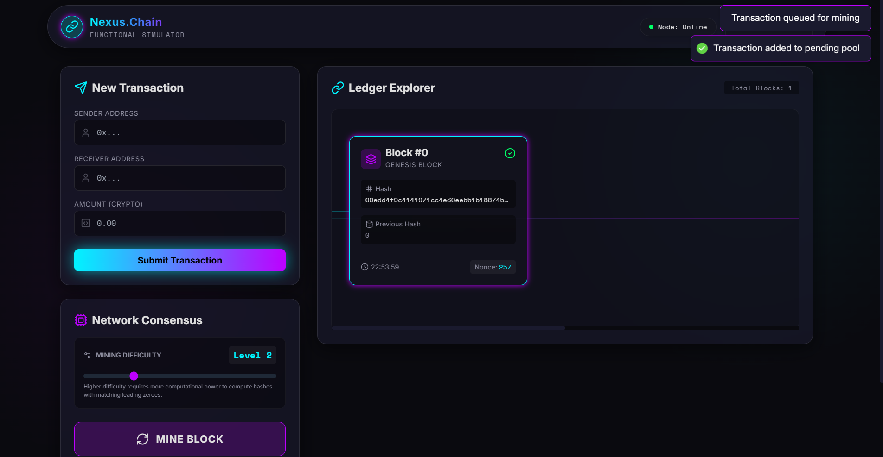

Figure 4: Transaction Successfully Added to Transaction Pool
Mining Process Execution & New Block Added to Blockchain
This screenshot demonstrates the mining process where the system generates a valid hash using the proof-of-work algorithm. During mining, the nonce value is repeatedly adjusted until a hash satisfying the required difficulty level is found. Once the valid hash is generated, the new block containing the transaction data is added to the blockchain and displayed in the ledger explorer.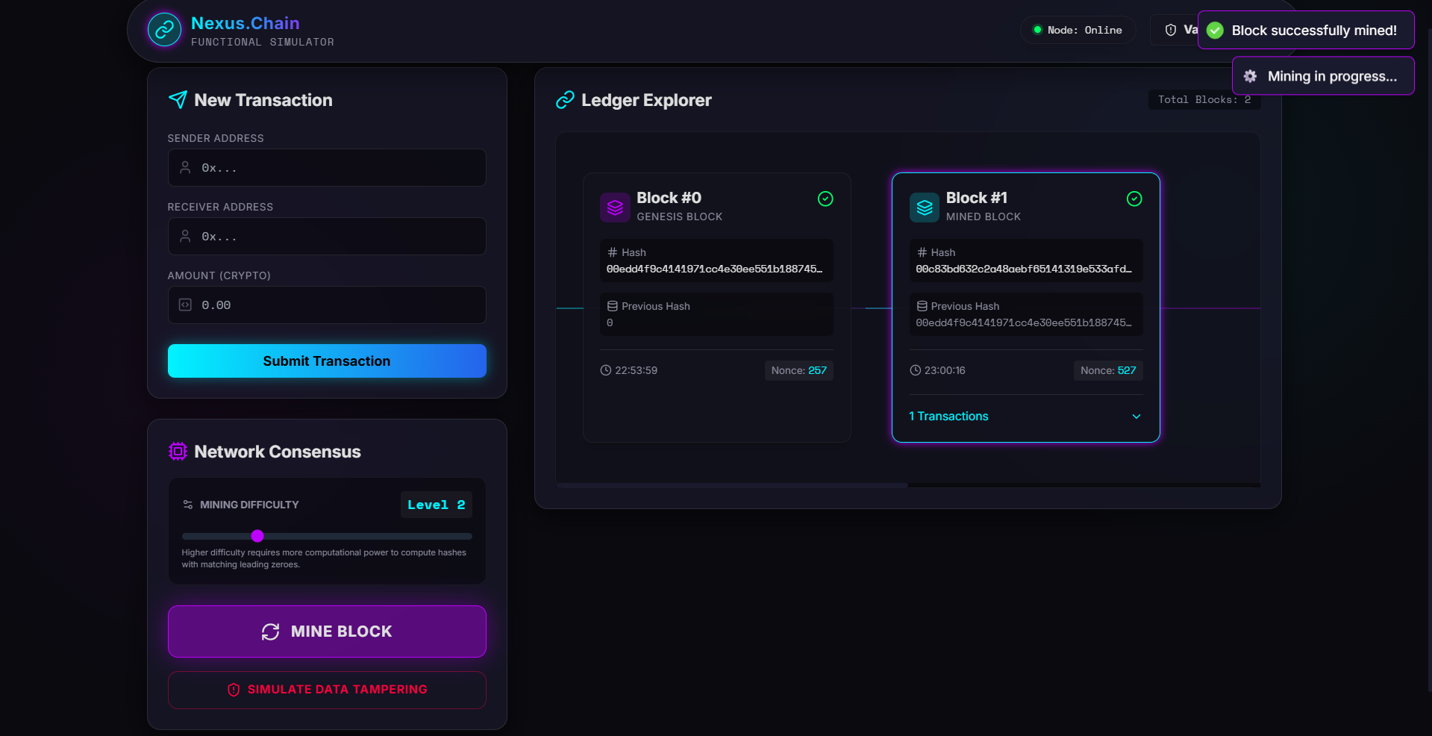
Figure 5: Block Mining Process Execution & Newly Generated Block Added to Blockchain
Blockchain Validation Result
This screen shows the blockchain validation result after blocks have been added to the chain. The system verifies the integrity of the blockchain by checking the hash values and the connections between blocks. If all conditions are satisfied, the blockchain is confirmed to be valid, ensuring that the stored data has not been tampered with.
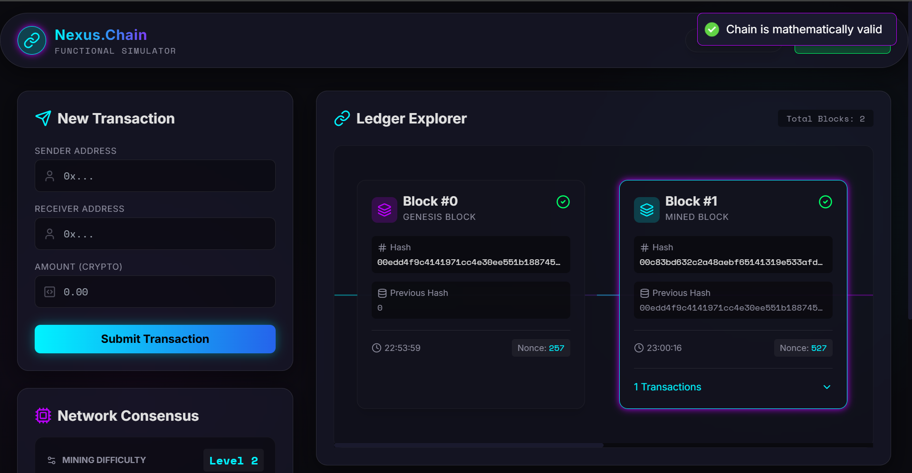

Figure 6: Blockchain Validation Result Showing Chain Integrity

9. Testing and Results
The system was tested to verify the correct functioning of the Functional Blockchain Simulator. Various test cases were performed to ensure that the system correctly handles transaction submission, block mining, and blockchain validation.
During testing, users entered transaction details through the interface and submitted them to the system. The application successfully processed the transactions and stored them in the transaction pool. When the mining process was initiated, the system generated a valid hash using the proof-of-work algorithm and created a new block containing the transaction data.
After mining, the new block was added to the blockchain and displayed in the ledger explorer. The blockchain validation mechanism then verified the integrity of the entire chain by checking the hash values and block connections.
All the input and output execution screenshots related to these test cases are provided in the Implementation section above. These screenshots demonstrate the successful execution of transaction processing, block mining, and blockchain validation.
The results confirm that the system functions correctly and successfully demonstrate the core concepts of blockchain technology using Haskell.

10. Discussion
Challenges Faced
During the development of the Functional Blockchain Simulator, several challenges were encountered. One of the main challenges was understanding and implementing blockchain concepts such as block creation, hashing, and proof-of-work mining using functional programming principles. Since Haskell follows a purely functional approach, managing program logic without mutable state required careful design of data structures and functions.
Another challenge was integrating the backend logic with the frontend interface. Ensuring smooth communication between the user interface and the Haskell backend through API requests required proper handling of data formats and responses. Additionally, implementing the mining algorithm efficiently while maintaining the correct blockchain structure required multiple tests and adjustments.

Debugging Strategy
To resolve these challenges, a systematic debugging approach was followed. The system was tested in small modules by verifying each function individually before integrating them into the complete system. Debugging techniques such as checking intermediate outputs, validating hash generation, and testing API responses were used to identify issues in the implementation.
Error messages and logs were carefully analyzed to detect problems in data handling and blockchain validation. Incremental testing helped ensure that each component of the system worked correctly before proceeding to the next stage of development. This step-by-step debugging process helped in successfully identifying and resolving issues during the implementation of the project.

11. Conclusion
The Functional Blockchain Simulator project successfully demonstrates the fundamental concepts of blockchain technology using the Haskell programming language. The system was designed to illustrate how blocks are created, how transactions are processed, and how blocks are securely linked together using cryptographic hashing. The implementation also includes a proof-of-work mining mechanism and a blockchain validation process to ensure the integrity of the chain.
Through this project, important functional programming concepts such as immutability, pure functions, algebraic data types, and modular system design were applied in a practical context. The project also provided experience in integrating backend logic with a frontend interface to create an interactive system. Overall, the project helped in understanding how blockchain systems maintain security, transparency, and data integrity while demonstrating the advantages of functional programming in developing reliable software systems.

12. Future Enhancement
Although the current system successfully demonstrates the core concepts of blockchain, several improvements can be made to extend its functionality in the future.
Some possible enhancements include implementing a distributed network where multiple nodes can maintain and validate the blockchain, which would better simulate real-world blockchain systems. Additional security mechanisms such as digital signatures and public-key cryptography can also be integrated to authenticate transactions.
The system can further be enhanced by improving the user interface with advanced blockchain visualization and real-time monitoring features. Another possible extension is to integrate database storage for persistent blockchain data instead of in-memory storage. These improvements would make the system more scalable and closer to real-world blockchain implementations.

13. References
- 23CSE212 – Functional Programming using Haskell Course Plan
- Nakamoto, S. (2008). Bitcoin: A Peer-to-Peer Electronic Cash System.
- Graham Hutton. Programming in Haskell. Cambridge University Press.
- Bryan O’Sullivan, Don Stewart, John Goerzen. Real World Haskell.
- Daniel Drescher. Blockchain Basics.

14. GitHub Link
https://github.com/dhanush296/functional-blockchain-simulator-haskell

